Laboratorio:
- Git
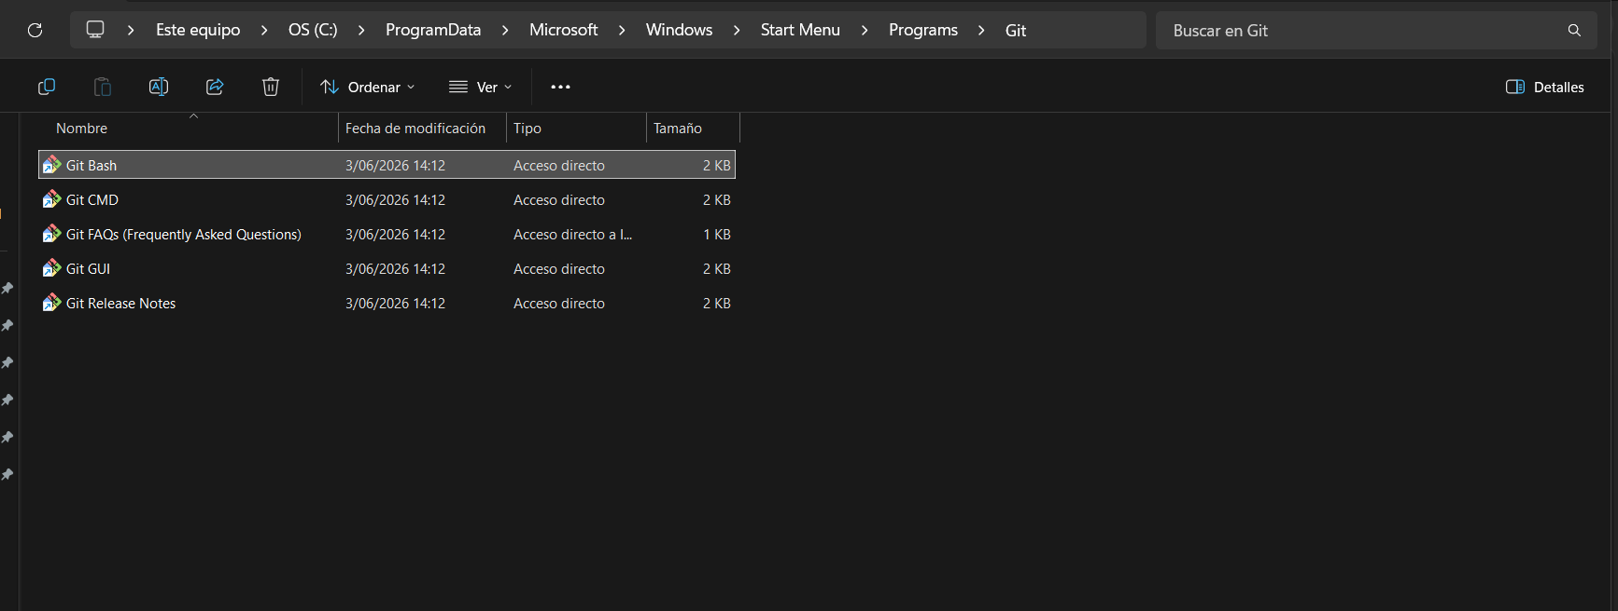
- Github
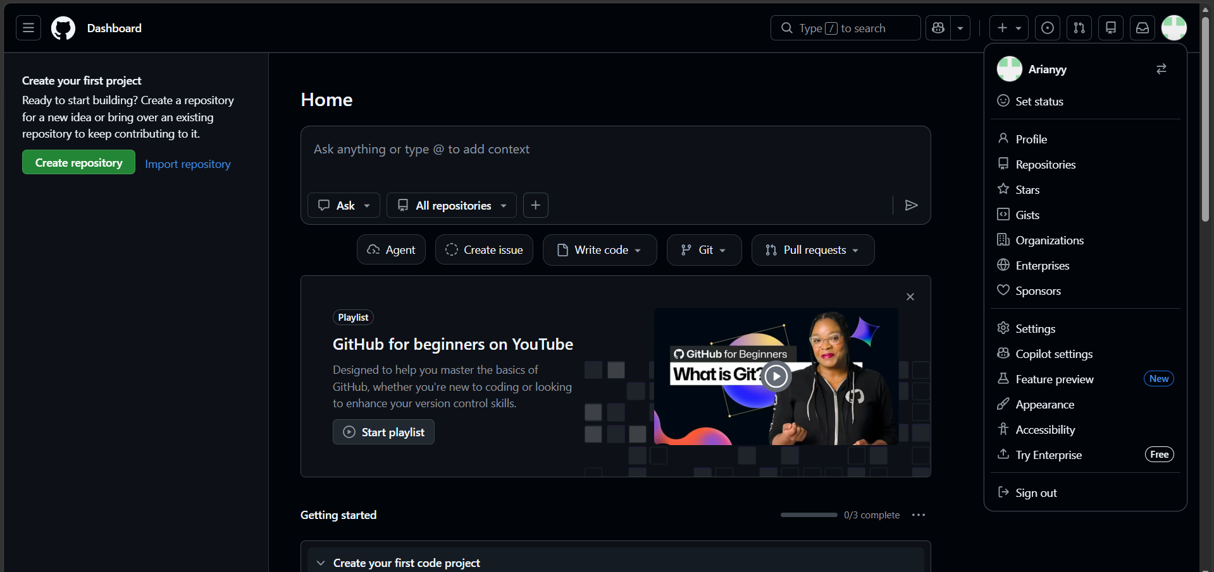
- Visual Studio Code
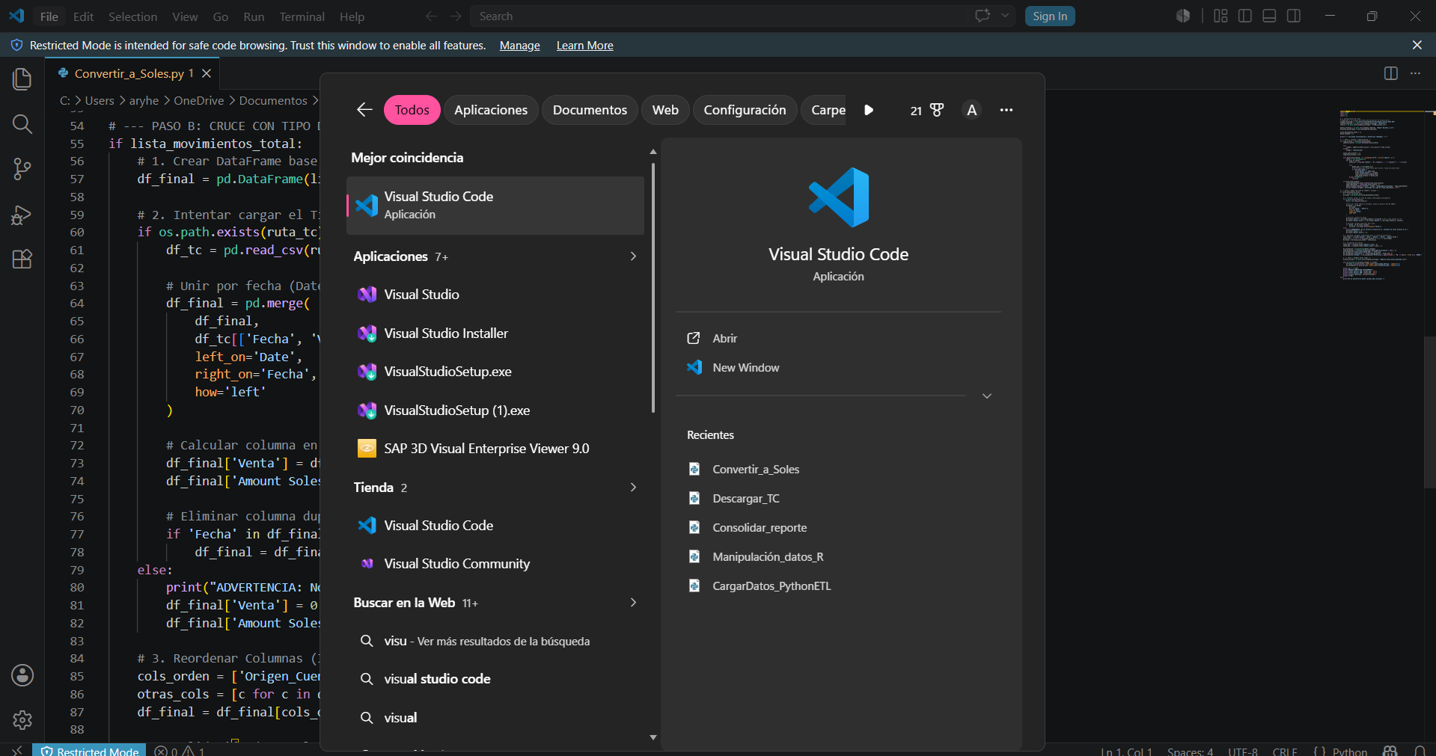
- Docker Desktop
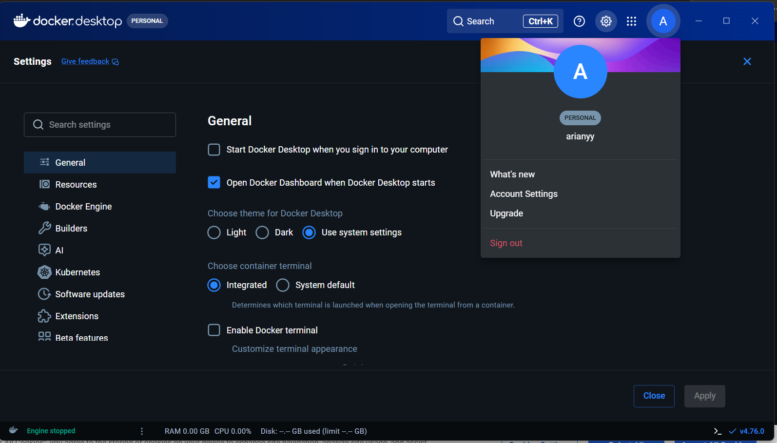
- Python 3
- PostgreSQL
- Jenkins
- Terraform

